Assignment 1

* IAM USER CASE: Creation of IAM account to have Full access to S3 Service.
* Setting up Custom Sign-in URL || MFA

Go to IAM, click on create user, give the username and generate password for user. Next, set permissions for accessing s3 service, select Amazons3FullAccess policy.

We can login through the IAM user credentials generated by root account and access s3 service of root account, also we can perform all the operation s3 buckets.

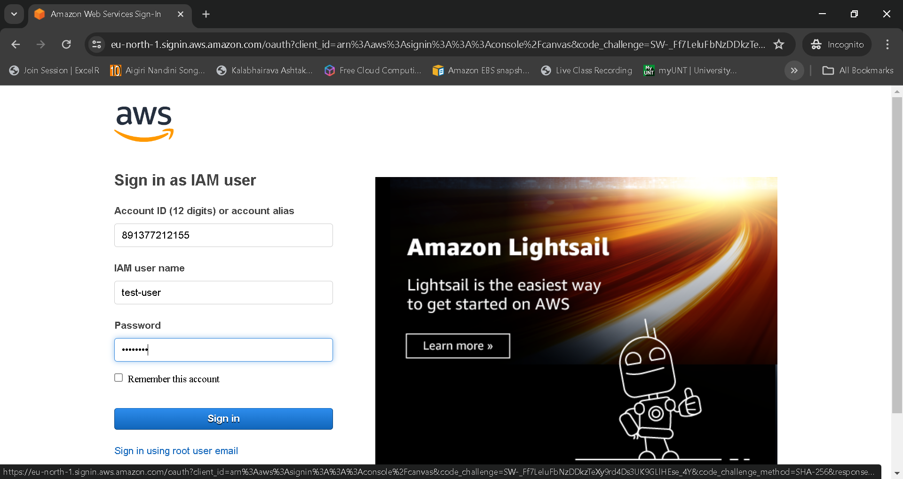

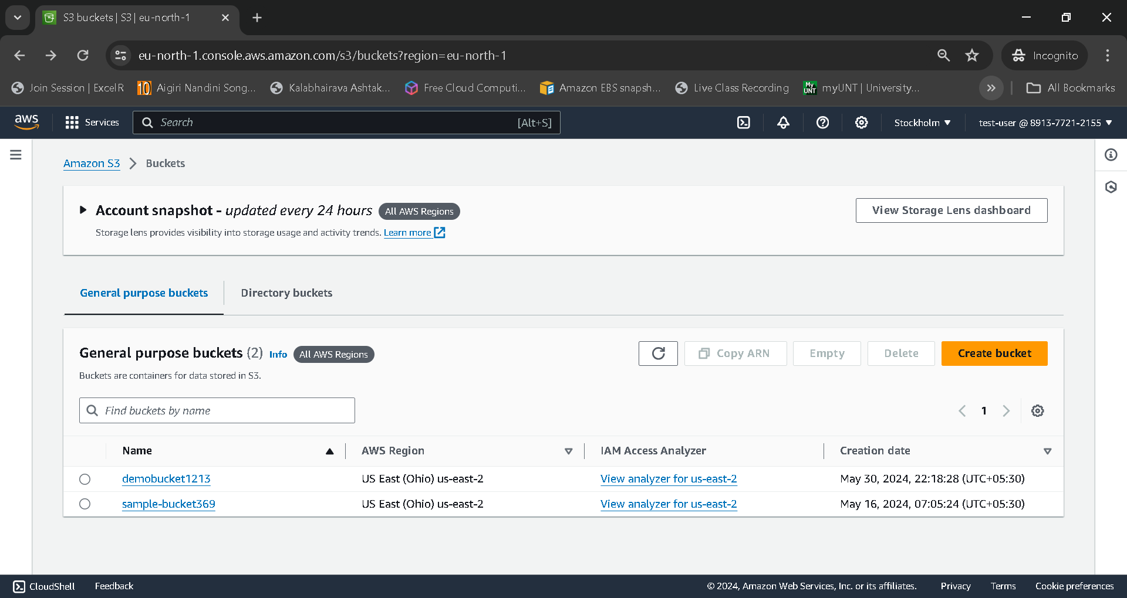

Add Multi-factor-authentication by clicking enable MFA for the custom IAM user, setup MFA by any authenticator like mobile apps(DUO), enter the code from the authenticator app while logging in to the console.

